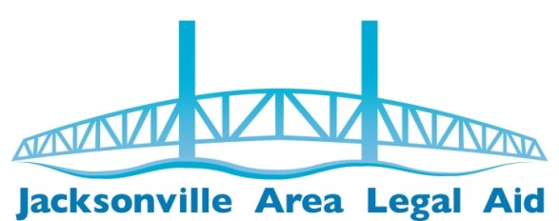
2019 SUSTAINING LAW FIRMS
Thanks for your support!

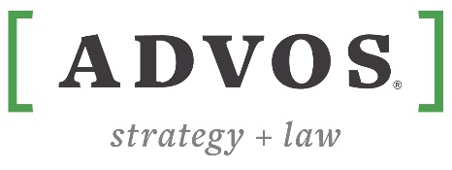
ADVOS legal pllc

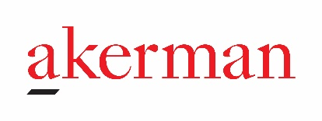
Akerman LLP


Bedell, Dittmar, DeVault, Pillans & Coxe, P.A.

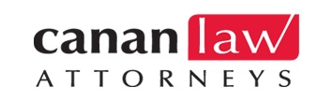
Canan Law Attorneys

Jacksonville Disability Law
Chantal Jacqueline Harrington, PA

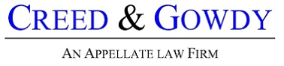
Creed & Gowdy

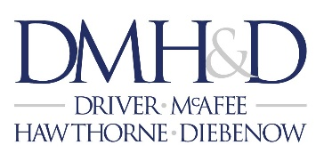
Driver, McAfee, Hawthorne & Diebenow

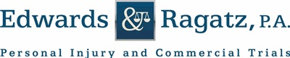
Edwards & Ragatz, P.A.

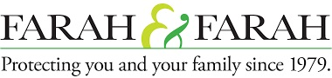
Farah & Farah


Gunster


Harrell & Harrell


Holland & Knight

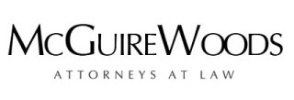
McGuire Woods

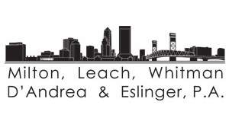
Milton, Leach, Whitman, D'Andrea & Eslinger, P.A.

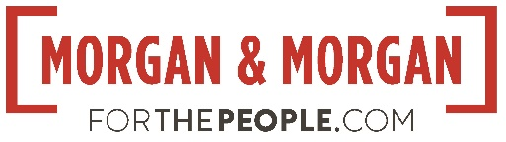
Morgan & Morgan


Nelson Mullins Riley & Scarborough LLP


Ossi & Najem, P.A.
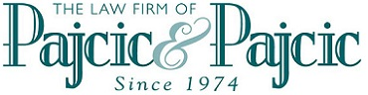
Pajcic & Pajcic

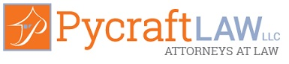
Pycraft Law LLC

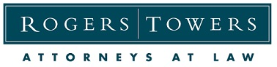
Rogers Towers, P.A.


Ronald E. Sholes, P.A.


Shutts & Bowen, LLP
Spohrer & Dodd, P.L.


Shuster & Saben LLC


Terrell Hogan


Weaver & Weaver

