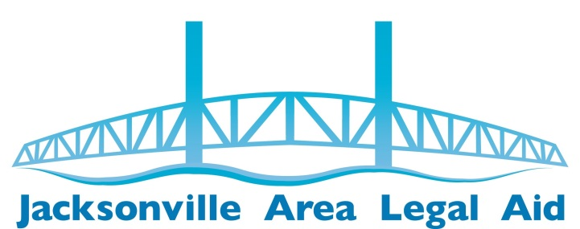
2016/2017 SUSTAINING LAW FIRMS
Thanks for your support!

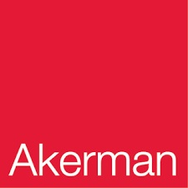
Akerman LLP

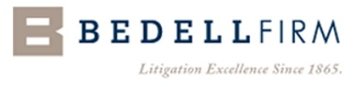
Bedell, Dittmar, DeVault, Pillans & Coxe, P.A.

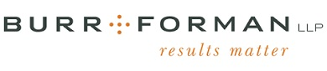
Burr & Forman

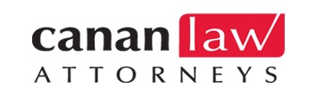
Canan Law Attorneys

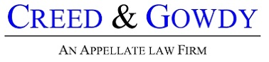
Creed & Gowdy

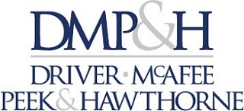
Driver, McAfee, Peek & Hawthorne

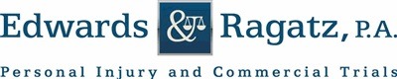
Edwards & Ragatz, P.A.

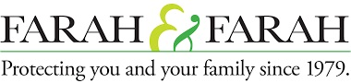
Farah & Farah

Gunster

Harrell & Harrell

Holland & Knight

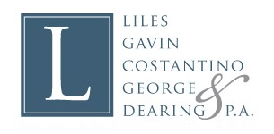
Liles, Gavin, George, Carlisle, Lee & Callen, P.A.

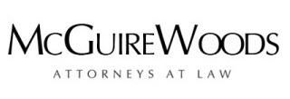
McGuire Woods

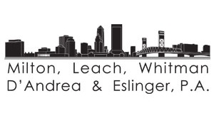
Milton, Leach, Whitman, D'Andrea & Eslinger, P.A.

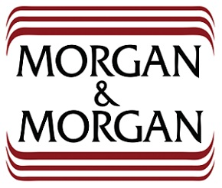
Morgan & Morgan

Nelson Mullins Riley & Scarborough LLP

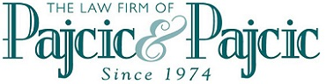
Pajcic & Pajcic

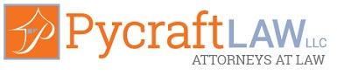
Pycraft Law LLC

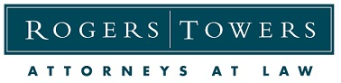
Rogers Towers, P.A.

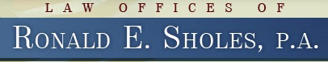
Ronald E. Sholes, P.A.

Spohrer & Dodd, P.L.

Shuster & Saben LLC

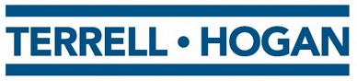
Terrell Hogan

