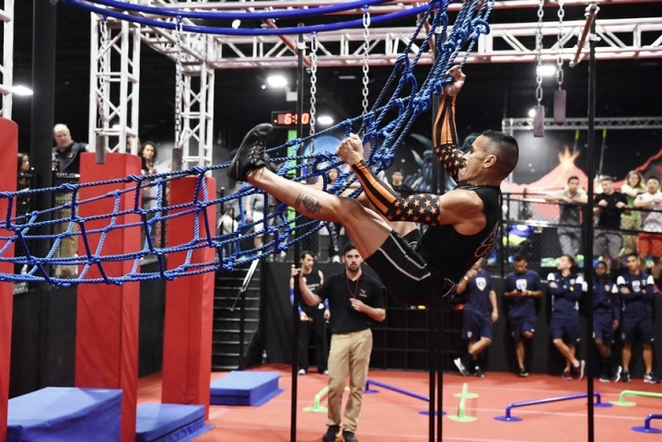
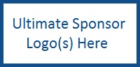
2017 Florida’s Ultimate
Ninja Warrior
Competition
Sponsored by:

$5000 - Ultimate Sponsorship
Strongest Ninja in the Village
- Present medal to UNAA winners at event
- Company name on medal
- Company name/logo on all signage at event
- Company name or logo on competitors t-shirts
- Display table at event
- Mentioned in all radio ads (total of 8 stations running 30 second ads)
- Mentioned in press release
- Link to company from event webpage
- Mentioned on event Facebook page minimum of 3 times
- Mentioned over loudspeaker at event
- 8 athlete registrations (you supply athletes/warriors)
- Name and logo and link in Jacksonville Area Legal Aid (JALA) e-newsletter twice (5000+ circulation)
- Name and logo on JALA Facebook
- JALA will like your company Facebook page
- JALA will follow you on twitter
- 10 spectator tickets to event (plus 1 to staff display table)
- 10 jump park tickets for event
$2500 - Advanced Sponsorship
Highly Skilled Ninja
- Present medal to one of the local winners at event
- Company name/logo on all signage at event
- Company name or logo on competitors t-shirts
- Display table at event
- Mentioned in all radio ads (total of 8 stations running 30 second ads)
- Link to company from event webpage
- Mentioned on event Facebook page minimum of 3 times
- Mentioned over loudspeaker at event
- 4 athlete registrations (you supply athletes/warriors)
- Name and logo and link in Jacksonville Area Legal Aid (JALA) e-newsletter twice (5000+ circulation)
- Name and logo on JALA Facebook
- JALA will like your company Facebook page
- JALA will follow you on twitter
- 5 spectator tickets for event (plus 1 to staff display table)
- 5 jump park tickets for event

$1000 - Basic Sponsorship
Journeyman Ninja
- Company name/logo on all signage at event
- Company name or logo on competitors t-shirts, and jerseys
- Display table at event
- Link to company from event webpage
- Mentioned on event Facebook page twice
- Mentioned over loudspeaker at event
- 2 athlete registrations (you supply athletes/warriors)
- Name and logo and link in Jacksonville Area Legal Aid (JALA) e-newsletter twice (5000+ circulation)
- Name and logo on JALA Facebook
- JALA will like your company Facebook page
- JALA will follow you on twitter
- 6 spectator tickets for event
- 1 jump park ticket for event

